

**Carrier 4.0HP A5CK 40E/A5LCY 40D**

**Rs. 110,700/-**

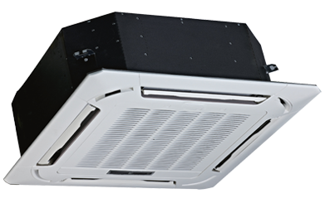

**Product Features**

* Easy Clean Panel
* Remote Control Pocket
* Three Minutes Protection
* Rust Resistant Cabinet
* Reserved Air Outlet

**Specification**

**Type** Ceiling Cassette AC

**Cooling (Btu/h)** 38000

**Voltage (V)** 220-240

**Power Input (W)** 5200

**EER (Btu/W-h-W/W)** 7.3-3.8